|  |  |
| --- | --- |
| PLANNING PROPOSAL  Amendment to the Narrabri Local Environmental Plan 2012 | image001 (2) |

**Planning Proposal 4/2019**

**Proposed Amendment to Narrabri Local Environmental Plan 2012**

**Amendment to include the Obstacle Limitation Surface Map**

**Version 01**

# PART 1: OBJECTIVES OR INTENDED OUTCOMES

## SECTION A – BACKGROUND

The Narrabri Airport is located approximately 8km east of the Narrabri town centre on Airport Road. It is owned and operated by Narrabri Shire Council and has two runways, Runway 18/36 and Runway 09/27. The Airport supports regular passenger transport air services to Sydney and Brisbane, as well as charter and other commercial and private aircraft operations whilst providing the economic life line for the resource industry and the broader regional community.

In 2011, Rehbein Airport Consulting prepared the Narrabri Airport Master Plan. This Plan underwent an Independent Review in May 2013 due to additional information and trends becoming apparent.

In June 2014, Aviation Projects prepared the Airport Master Plan 2014 – 2034 for Narrabri Shire Council. The purpose of the master planning study was to *“establish a framework for the future planning and development of Narrabri Airport to ensure the Narrabri region achieves its strategic objectives and capabilities on the aeronautical and commercial opportunities provided by the airport.”*

The objectives of the Master Plan are to:

* Take an integrated approach to aviation, land and commercial development;
* Develop a strategy to enable the continued safe operation of the airport in a financially responsible and feasible manner;
* Provide adequate facilities and services to support the growth in the resource and other industries in the area;
* Provide a service centre for private operators based in the Shire or needing to visit;
* Support emergency services activities;
* Attract aircraft related business, industry and support services; and
* Provide a heavy industry area to support 24 hour operations.

The Master Plan 2014 – 2034 makes a number of short, medium and long term recommendations ranging from rehabilitation of the existing runway, upgrading lighting, to upgrade and expansion of the terminal and strengthening, widening and extending the runway.

Council is currently considering concept plans and layouts that will see a new terminal building, new drop off/pick up area, new car park and a larger hanger precinct identified.

A recommendation is made within the Master Plan 2014 – 2034 short term that the Obstacle Limitation Surfaces (OLS) Plans prepared as part of the 2011 Master Plan should be incorporated into LEP 2012.

OLS are a series of surfaces that set the height limits of objects around an aerodrome. The OLS is defined by international specifications, as adopted by the Civil Aviation Safety Authority. Objects that project through the OLS become obstacles. The purpose of the OLS is to ensure that aircraft flying in good weather during the initial and final stages of flight, or in the vicinity of the airport, can do so safely.

OLS for current and ultimate aerodrome layouts were prepared and included in the 2011 Master Plan.

Whilst the Narrabri LEP 2012 contains Clause 6.3 Airspace Operation along with reference to OLS Map, there is no map contained within the LEP. The purpose of this planning proposal is to include the OLS Map. No further modifications are proposed. It is unknown why the OLS Maps where not included in the LEP 2012, it may be as a result of recognition that these maps can be amended at short notice subject to the change of airport operations.

This document sets out the justification for and explains the intended effect of the recommended amendment.

## SECTION B – OBJECTIVES

The objectives and intended outcomes of this planning proposal is to ensure the effective and safe operation of the Narrabri Airport whilst ensuring that the operation of the airport is not compromised by development that constitutes an obstruction, hazard or potential hazard to aircraft flying in the vicinity.

# PART 2: EXPLANATION OF PROVISIONS

The proposed objectives will be achieved by:

1. Inserting the Obstacle Limitation Surface Map as shown in Attachment 1 into LEP 2012 and provided below;
2. Replace Clause 6.3(5) of LEP 2012 to refer to the Obstacle Limitation Surface Map as follows;

6.3(5) In this clause:

***obstacle height limit*** means the land shown as “Obstacle Height Limitations Surface Height Map”.

***relevant Commonwealth body*** means the body that is responsible for development approvals for development that penetrates the Obstacle Height Limitation for the Narrabri Airport.

1. Include the following definition in the Dictionary;

***Obstacle Limitation Surface Map*** means the Narrabri Local Environmental Plan 2012 Obstacle Limitation Surface Map.

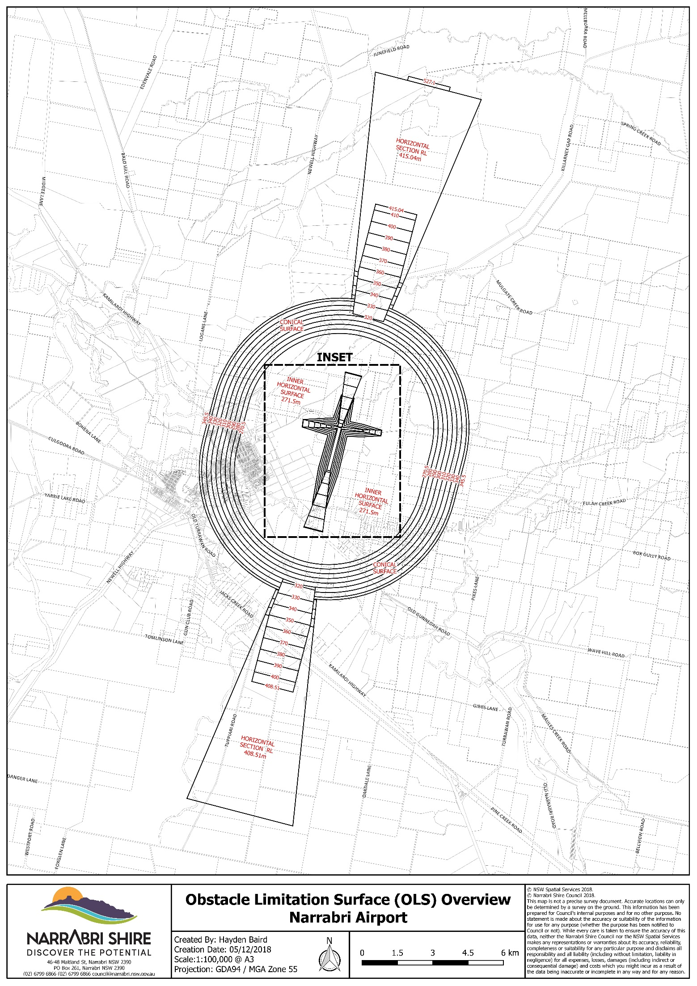

# PART 3: JUSTIFCATION

In accordance with the Department of Planning and Infrastructure’s *Guide to Preparing Planning Proposals,* this section considers the following issues:

* Section A: Need for the planning proposal
* Section B: Relationship to strategic planning framework
* Section C: Environmental, social and economic Impact
* Section D: State and Commonwealth Interests

## SECTION A – NEED FOR THE PLANNING PROPOSAL

1. **Is the planning proposal the result of any strategic study?**

The planning proposal is not a direct result of a strategic study or report. However, as outlined above, in 2014, Narrabri Shire Council adopted the *Narrabri Airport Master Plan 2014 – 2034* which *“establishes a framework for the future planning and development of the Narrabri Airport to ensure the Narrabri region achieves its strategic objectives and capiltalises on the aeronautical and commercial opportunities provided by the airport.”*

OLSs’ for current and ultimate aerodrome layouts where prepared and included in the 2011 Master Plan, and again in the 2014 Master Plan but where not included in LEP 2012.

1. **Is the planning proposal the best means of achieving the objectives or intended outcomes or is there a better way?**

It is considered that an amendment to the Narrabri LEP 2012 is the only method to achieve the objectives and outcome sought by this planning proposal.

## SECTION B –RELATIONSHIP TO STRATEGIC PLANNING FRAMEWORK

1. **Is the planning proposal consistent with the objectives and actions contained within the applicable regional or sub-regional strategy?**

The *New England North West Regional Plan 2036*, hereafter referred to as the *Regional Plan*, was prepared by the Department of Planning and Environment to give strategic direction to development in the New England North West Region and is a relevant consideration for this planning proposal.

The *Regional Plan* recognises the network of regional cities and centres support diverse industries and that as their industries grow, centres will thrive and require high quality health, education and recreation options. The *Regional Plan* goes on to further recognise the regional cities of Tamworth and Armidale and the strategic centres of Narrabri, Moree, Inverell and Glen Innes will be the focus of employment and services.

The *Regional Plan* sets out four regionally focused goals and Direction’s and Actions as policy measures targeted toward achieving the Plans goals.

The goals of the *New England North West Regional Plan 2036* are:

Goal 1 – A strong and dynamic regional economy

Goal 2 – A healthy environment with pristine waterways

Goal 3 – Strong infrastructure and connected transport networks for a connected future

Goal 4 – Attractive and thriving communities

*Direction 15: Facilitate air and public transport infrastructure* under *Goal 3* of the *Regional Plan* recognises that regional airports are important gateways for business, tourism and personal travel and high value freight. They also provide services for fly-in fly-out workers and access to specialist health, education and commercial facilities.

Action 15.2 states *“Protect airports from the encroachment of incompatible development.”*

The inclusion of the OLS Map into LEP 2012 will assist in protecting the airport from encroachments of incompatible development.

1. **Is the planning proposal consistent with the local Council’s Community Strategic Plan or other local strategic plan?**

The *Community Strategic Plan 2027* presents the community endorsed vision and strategic plan for Narrabri Shire which was prepared in 2017 and relates to the entirety of the Narrabri Local Government Area.

The Strategic Plan’s vision is *“Narrabri Shire will be a strong and vibrant regional growth centre providing a quality living environment for the entire Shire community.”*

Under Community aspirations for the future in *Theme 3: A place to thrive – a strong diverse economy that attracts and retains business, services and tourist*, the description for Transport Network is:

*Our community is easy to access and east to get around. Our main roads are kept in good condition and repaired promptly after damage. We have an organised and streamlined approach to restoring normality after flood and other emergencies. Businesses and residents should be able to rely on easy and affordable access to major cities by air. Businesses are well connected to other transport hubs in the state, while residents willingly use well run public transport services. There is ample parking in and around our main street.*

Specific mention is made of Narrabri Airport under *What Will We Do, Theme 3: A place to thrive – a strong diverse economy that attracts and retains businesses, services and tourist:*

|  |  |  |
| --- | --- | --- |
| **Strategic Objective** | **Strategies** | **Measurements of Success** |
| PT2  Airport to be of regional quality (similar to Newcastle) | PT2.1 Develop and implement Airport Asset Management Plan  PT2.2 Potential airlines supported affordable and encouraged through improved infrastructure | * Adequate air transport in Narrabri Shire. * Air transport more accessible and affordable. |

This planning proposal does not directly relate to any provisions of the *Strategic Plan*, however it is considered that it proactively protects the Narrabri Airport ensuring its continued operation and opportunity to develop further.

1. **Is the planning proposal consistent with applicable State Environmental Planning Policies?**

Yes. This planning proposal is considered to be consistent with relevant State Environmental Planning Policies (SEPPs) and does not seek any variations to the requirements set out in the SEPPs. The inclusion of the OLS Map into Narrabri LEP 2012 does not impact upon any SEPPs, with any development that may be proposed that is affected by the OLS Map being required to consider and address the applicable SEPP.

Narrabri LEP 2012 is based on the Standard Instrument LEP and contains Clause 6.3 Airspace Operations which does not permit for a development to be granted that will penetrate the Limitation or Operations Surface of the Airport unless the relevant Commonwealth body has advised it does not have an objection to the proposal. Nothing proposed in this planning proposal modifies this clause or requirement. The planning proposal does include an update to Clause 6.3 to include specific reference to the Obstacle Limitation Surface Map along with including a definition of the Map in the Dictionary.

1. **Is the planning proposal consistent with applicable Ministerial Directions (s.117 Directions)?**

The Minister for Planning issues Local Planning Directions that Council must follow when preparing a planning proposal. The directions cover the following broad categories:

* Employment and resources
* Environment and heritage
* Housing, infrastructure and urban development
* Hazard and risk

Each S. 9.1 Ministerial Direction is listed below (Table 1) with an annotation stating whether it is relevant to the planning proposal and comments relating to its consistency with the corresponding objective. The planning proposal has considered all Ministerial Directions and is consistent with all Local Planning Directions.

| **S. 9.1 Direction Title** | **Consistency of Planning Proposal** |
| --- | --- |
| 1.1 Business and Industrial Zones | Not applicable. The planning proposal does not propose to rezone land and will not affect the provision of this Direction. |
| 1.2 Rural Zones | Consistent. Whilst the planning proposal does not propose to rezone land and will not affect the provision of this Direction, Rural zoned land surrounding the Narrabri Airport is affected by the OLS Map. The planning proposal is unlikely to directly impact on the agricultural production value of the Rural zoned land. |
| 1.3 Mining, Petroleum Production and Extractive Industries | Not applicable.  The subject lands are not identified as a State or regionally significant reserve of coal, other minerals, petroleum and extractive material. |
| 1.4 Oyster Aquaculture | Not applicable. |
| 1.5 Rural Lands | Consistent. Whilst the planning proposal does not propose to rezone land and will not affect the provision of this Direction, Rural zoned land surrounding the Narrabri Airport is affected by the OLS Map. The planning proposal is unlikely to directly impact on the agricultural production value of the Rural zoned land nor the potential economic development of this land for rural and related purposes. Under existing Clause 6.3 Airspace Operation of LEP 2012, any proposal that will penetrate the Limitation or Operations Surface of the Narrabri Airport cannot be granted consent. This requirement is not proposed to be modified by this planning proposal. |
| 2.1 Environment Protection Zones | Consistent. The inclusion of the OLS Map as part of this planning proposal does impact upon some E1 – National Parks and Nature Reserve zoned land (Killarney State Conservation Area) approximately 8km to the north of the Airport. The planning proposal does not propose to rezone land and will not affect the provision of this Direction as environmentally sensitive land will continue to be protected. |
| 2.2 Coastal Management | Not applicable. |
| 2.3 Heritage Conservation | Consistent. Items of environmental heritage significance and indigenous heritage significance will continue to be conserved and protected. Under existing Clause 6.3 Airspace Operation of LEP 2012, any proposal that will penetrate the Limitation or Operations Surface of the Narrabri Airport cannot be granted consent. This requirement is not proposed to be modified by this planning proposal. |
| 2.4 Recreation Vehicle Areas | Not applicable. |
| 2.5 Application of E2 and E3 Zones and Environmental Overlays in Far North Coast LEPs | Not applicable. |
| 3.1 Residential Zones | Consistent. The inclusion of the OLS Map as part of this planning proposal does impact upon some Residential zoned land within the town of Narrabri. However, the planning proposal does not propose to rezone land and will not affect the provision of this Direction as Residential land will continue to be subject to the existing provisions of LEP 2012 including Clause 6.3 where appropriate. |
| 3.2 Caravan Parks and Manufactured Home Estates | Consistent. The planning proposal does not propose to rezone land and will not affect the provision of this Direction. |
| 3.3 Home Occupations | Consistent. The planning proposal does not propose to alter the provisions of the principle LEP which provides for this use without consent in most circumstances. |
| 3.4 Integrating Land Use and transport | Consistent. The planning proposal does not propose to rezone land and will not affect the provision of this Direction. |
| 3.5 Development Near Licensed Aerodromes | Consistent. The purpose of this planning proposal is to include the OLS Maps within the LEP 2012. This will ensure the effective and safe operation of the Narrabri Airport whilst ensuring its preparation is not compromised by development that constitutes an obstruction, hazard or potential hazard to aircraft flying in the vicinity. This planning proposal does not propose to rezone land nor change any of the existing provisions included in LEP 2012. The Department of the Commonwealth responsible for aerodromes along with any other relevant agencies will be consulted as required by the Gateway determination. |
| 3.6 Shooting Ranges | Not applicable. There are no shooting ranges affected by the planning proposal. |
| 4.1 Acid Sulfate Soils | Not applicable. |
| 4.2 Mine Subsidence and Unstable Land | Not applicable. |
| 4.3 Flood Prone Land | Consistent. The planning proposal does not directly affect provisions relating to flood prone land. Flood policy would continue to be enforced on flood-prone land. |
| 4.4 Planning for Bushfire Protection | Consistent. The planning proposal will not affect existing bushfire protection provisions. These provisions will continue to be enforced for developments on bushfire prone land. |
| 5.1 Implementation of Regional Strategies (Revoked 17 October 2017) | Not applicable. |
| 5.2 Sydney Drinking Water Catchments | Not applicable. |
| 5.3 Farmland of State and Regional Significance on the NSW Far North Coast | Not applicable. |
| 5.4 Commercial and Retail Development along the Pacific Highway, North Coast | Not applicable. |
| 5.5 Development in the vicinity of Ellalong, Paxton and Millfield (Cessnock LGA) (Revoked 18 June 2010) | Not applicable. |
| 5.6 Sydney to Canberra Corridor (Revoked 10 July 2008) | Not applicable. |
| 5.7 Central Coast (Revoked 10 July 2008) | Not applicable. |
| 5.8 Second Sydney Airport: Badgerys Creek | Not applicable. |
| 5.9 North West Rail Link Corridor Strategy | Not applicable. |
| 5.10 Implementation of Regional Plans | Consistent. As outline in Section B of this planning proposal the New England North West Regional 2036 Action 15.2 Action states *“Protect airports from the encroachment of incompatible development.”*  The inclusion of the OLS Map into LEP 2012 will assist in protecting the airport from encroachments of incompatible development and ensure the ongoing effective and safe operation of the Narrabri Airport. |
| 6.1 Approval and Referral Requirements | Consistent. The planning proposal does not propose any new provisions that require the concurrence, consultation or referral of development applications to a Minister or public authority. The inclusion of the OLS Maps within LEP 2012 will provide a visual map to any potential developers and the community regarding the application of Clause 6.3 Airspace Operations. |
| 6.2 Reserving Land for Public Purposes | Not applicable. |
| 6.3 Site Specific Provisions | Not applicable. |
| 7.1 Implementation of A Plan for Growing Sydney | Not applicable. |
| 7.2 Implementation of Greater Macarthur Land Release Investigation | Not applicable. |
| 7.3 Parramatta Road Corridor Urban Transformation Strategy | Not applicable. |
| 7.4 Implementation of North West Priority Growth Area Land Use and Infrastructure Implementation Plan | Not applicable. |
| 7.5 Implementation of Greater Parramatta Priority Growth Area Interim Land Use and Infrastructure Implementation Plan | Not applicable. |
| 7.6 Implementation of Wilton Priority Growth Area Interim Land Use and Infrastructure Plan | Not applicable. |
| 7.7 Implementation of Glenfield to Macarthur Urban Renewal Corridor | Not applicable. |

Table 1: SECTION 9.1 MINISTERIAL DIRECTIONS AND CONSUISTANCY WITH THIS PLANNING PROPOSAL

**SECTION C – ENVIRONMENTAL SOCIAL AND ECONOMIC IMPACT**

1. **Is there any likelihood that critical habitat or threatened species, populations or ecological communities, or their habitats, will be adversely affected as a result of the proposal?**

No. The planning proposal will not impact upon critical habitats, threatened species, populations or ecological communities of their habitats.

1. **Are there any other environmental effects as a result of the planning proposal and how are they proposed to be managed?**

No. The planning proposal will not have any likely environmental effects.

1. **How has the planning proposal adequately addressed any social and economic effects?**

The protection of the Narrabri Airport to ensure its ongoing effective and safe operation will have positive social and economic effects to not only the town of Narrabri but the great area serviced by the airport.

As outlined in Section B Part 4 of this planning proposal, Council’s *Community Strategic Plan,* the Narrabri Airport plays an important role in ensuring that Narrabri has a strong diverse economy that attracts and retains business, services and tourists.

**SECTION D – COMMONWEALTH AND STATE INTERESTS**

1. **Is there adequate public infrastructure for the planning proposal?**

Not applicable. It is considered that there are no additional infrastructure implications from this planning proposal.

1. **What are the views of State and Commonwealth public authorities in accordance with the Gateway determination?**

Relevant State and Commonwealth Government Agencies will be consulted in accordance with the requirements of any Gateway Determination.

**PART 4: MAPPING**

This planning proposal includes the OLS Map contained in Attachment 1.

**PART 5: COMMUNITY CONSULTATION**

In accordance with the *NSW Department of Planning Guidelines to preparing LEP’s*, upon Gateway Determination adjoining landholders and any affected community organisations will be formally notified of the proposal and invited to provide comment.

In accordance with prevailing Departmental Guidelines and the provisions of the Environmental Protection Authority Act, the planning proposal will also be notified publicly for the prescribed period in local newspapers and Council’s website at <http://www.narrabri.nsw.gov.au/>

Public exhibition will be carried out in accordance with the requirements of the EPA Act, EPA Regulations and the Gateway Determination.

**PART 6: PROJECT TIMELINE**

It is expected that the relevant steps in the planning proposal process will be completed as set-out in the table below:

|  |  |
| --- | --- |
| **Milestone** | **Timeframe** |
| Council endorse the Planning Proposal | December 2018 |
| Gateway Determination issued by the Department of Planning and Environment | February 2019 |
| Completion of technical assessment | March 2019 |
| Public exhibition of the planning proposal and any required consultation with any public authorities | April 2019 |
| Consideration of any submissions received made during public notification/consultation | May 2019 |
| Refer proposal to Parliamentary Counsel and obtain Opinion | June 2019 |
| Determination to make the LEP and notification of the LEP on legislation website | July 2019 |

**Note:** this project timeline has been drafted on the assumption that Council will be permitted to utilise its delegated plan making powers by the Department of Planning and Environment. Timeframes for achieving milestones may be subject to change pending issues arising during the planning proposal process.